1. 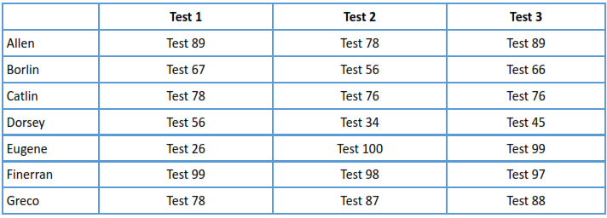You should form a table on a worksheet titled “class list” that includes the names and test scores of your students. You have 7 students in your class, their names are: Allen, Borlin, Catlin,Dorsey, Eugene, Finneran, and Greco. Their scores on the first 3 tests are as follows:
   1. Using an Excel function, show each student’s average in an additional column labelled “Average”

**Answer:**



* 1. Using an Excel function, show each student’s rounded average in an additional column labeled “Rounded Average”

**Answer:**



* 1. If a student’s rounded average is above “95”, he/she has received “honors” in the class. In an additional column titled “Honors”, insert a function that will return the word “Yes” if they have received honors, otherwise would return the word “No”

**Answer:**



* 1. If a student’s rounded average is 90 or greater, they receive an “A”. Between 80 and 90 is a “B”, between 70 and 80 is a “C”, between 60 and 70 is a “D”, and lower than 60 is an “F”. Somewhere on your sheet, enter this information in cells. Create an additional column titled “Grade” and insert a nested IF function that returns the appropriate grade for each student. Use an absolute cell references in your nested IF function to indicate cut-off points between grades. Hint: You will need to place the “cut-off grade” values in cells somewhere on your worksheet.

**Answer:**



|  |  |
| --- | --- |
| Cut-off | Grade |
| 90 | A |
| 80 | B |
| 70 | C |
| 60 | D |
| 59 | F |